**Problem**: a user want to install tomcat using ansible.

**Statement**: The user check the documentation available in internet

<https://www.digitalocean.com/community/tutorials/how-to-install-apache-tomcat-10-on-ubuntu-20-04>

Write Down all the steps needed to install tomcat from a repository.

But the above mentioned document shows How to install tomcat using traditional way through linux command line.

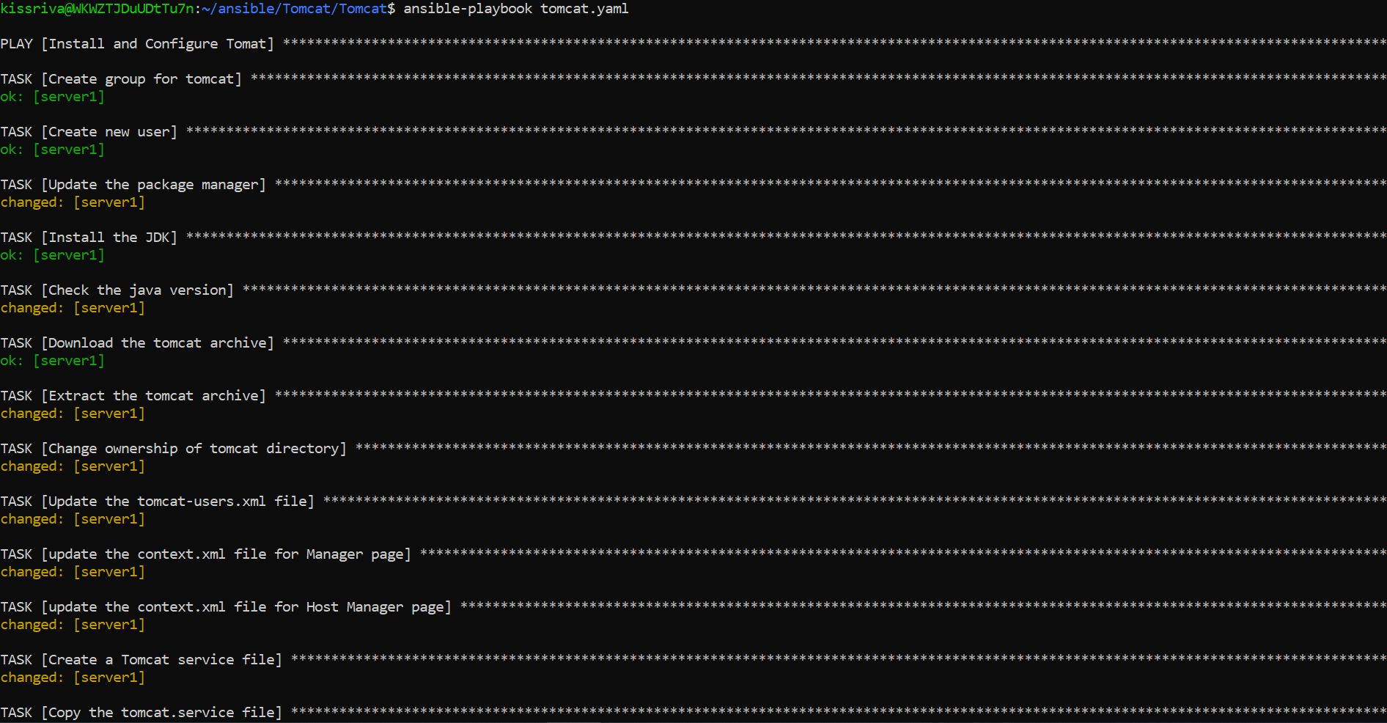

**Different steps of playbook execution**

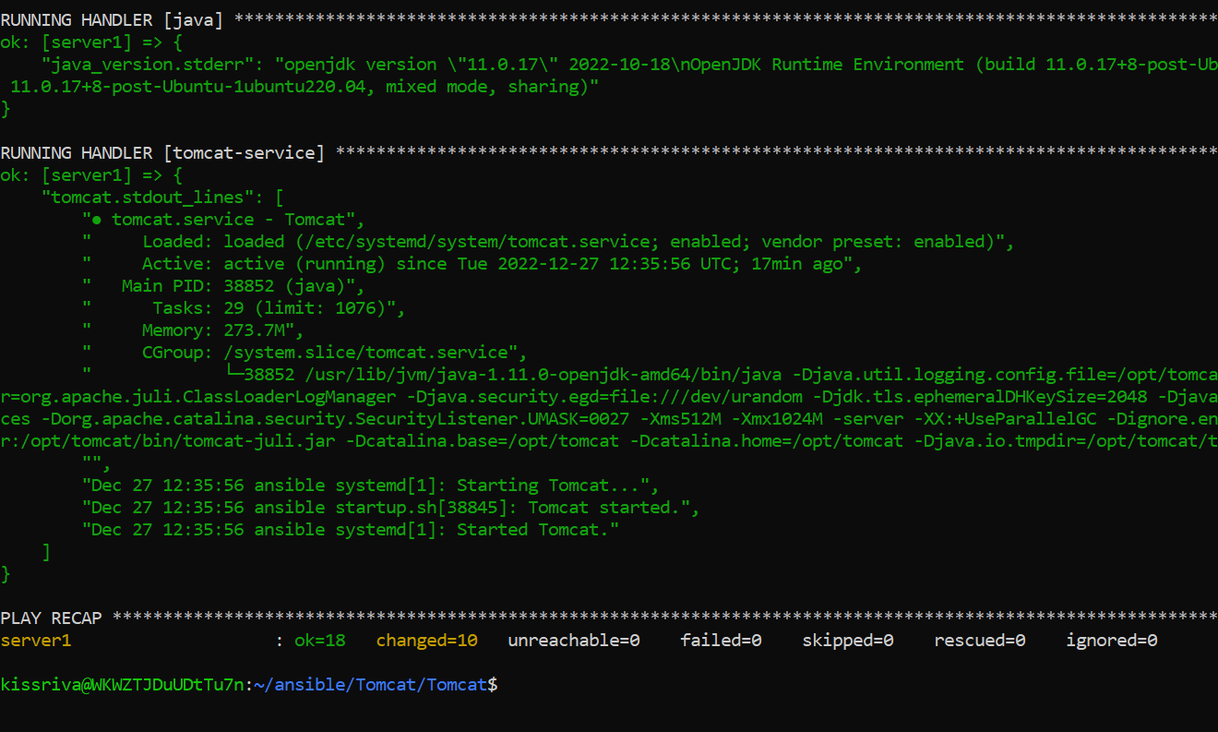

**Result of playbook execution**

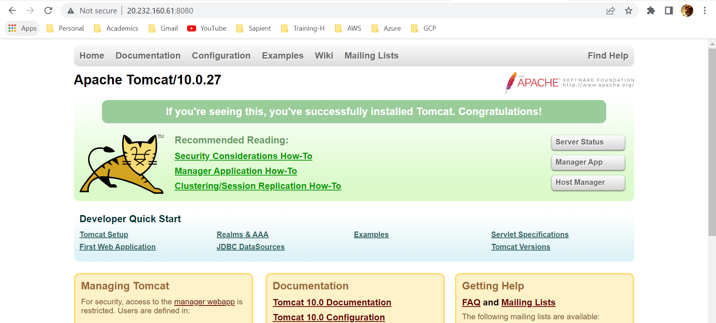

**Tomcat accessible on port 8080**

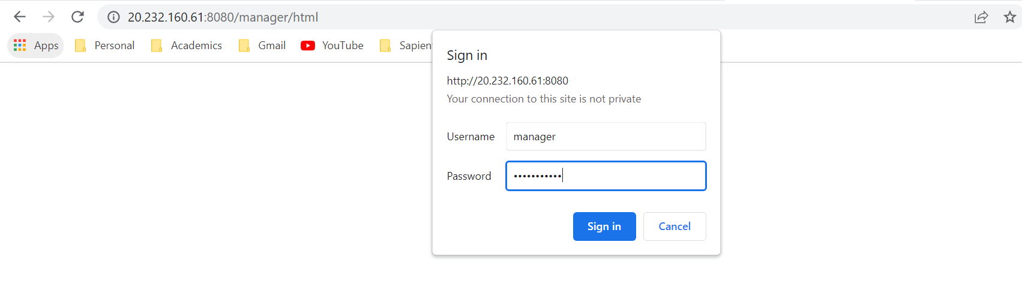

**Authentication to access Manager Page**

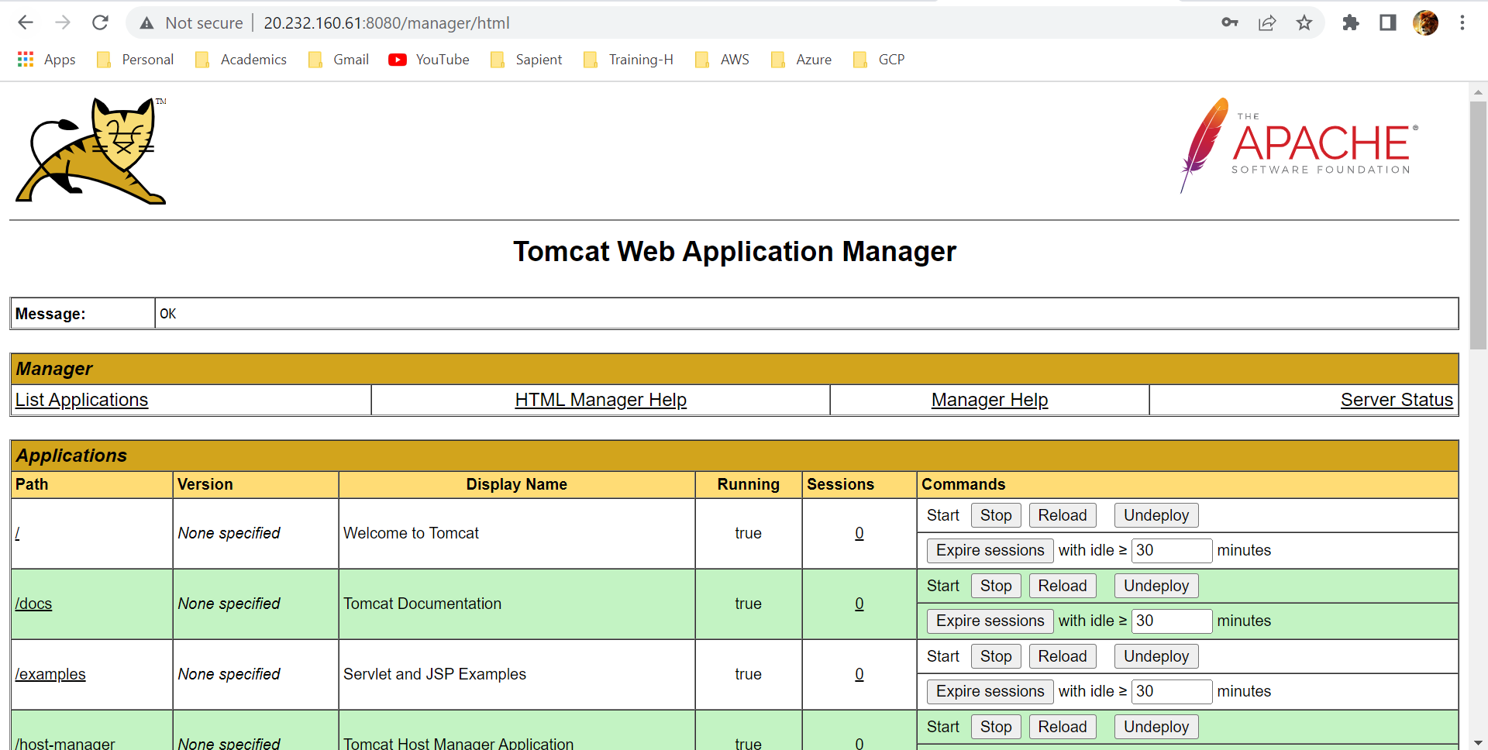

**Tomcat Web Application Manager Page**

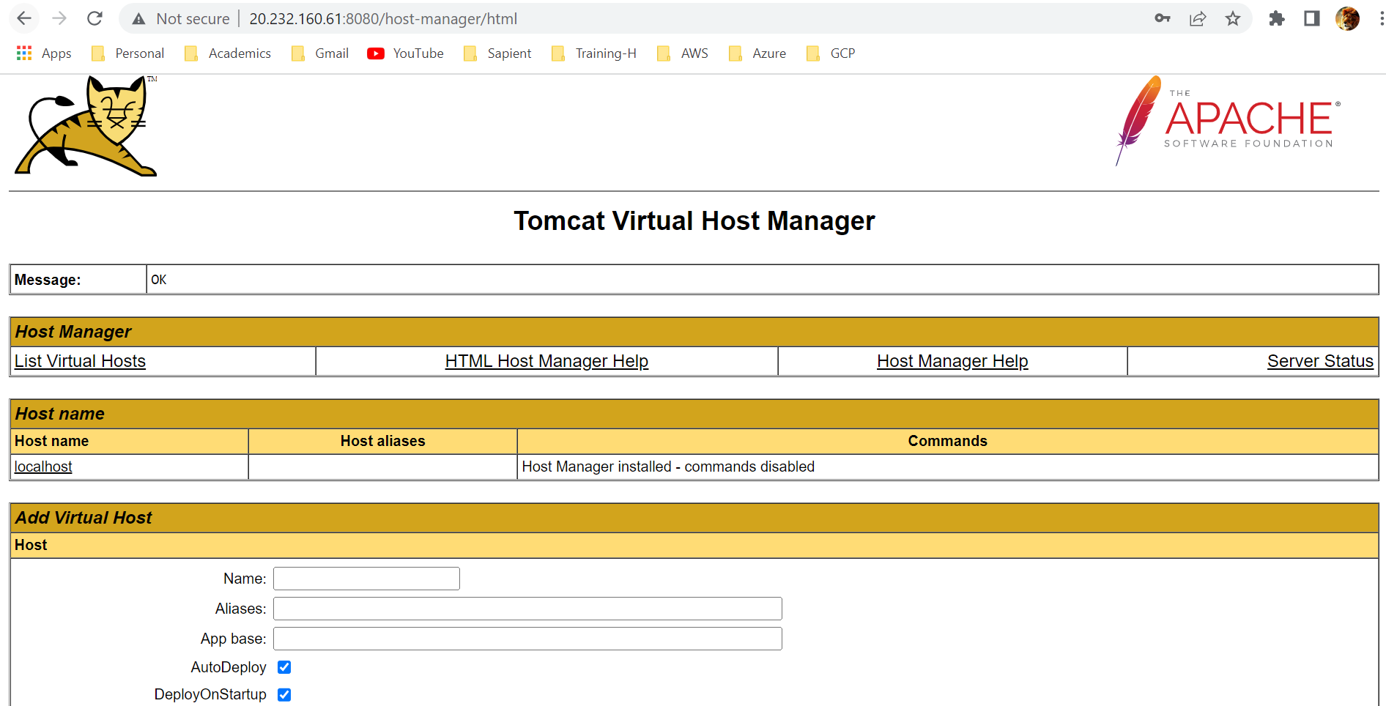

**Tomcat Virtual Host Manager Page**